# EARLY DETECTION OF FOREST FIRE USING DEEP LEARNING

**MODEL BUILDING INITIALIZING THE MODEL**

|  |  |
| --- | --- |
| Team ID | PNT2022TMID20340 |
| Project Name | Emerging methods of early detection of forest fire |

## INITIALILIZING THE MODEL:

keras has 2 ways to define a neural network:

* Sequential
* Function API

The Sequential class is used to define linear initializations of network layers which then, collectively, constitute a model. In our example below, we will use the Sequential constructor to create a model, which will then have layers added to it using the add () method.

Now, will initialize our model.

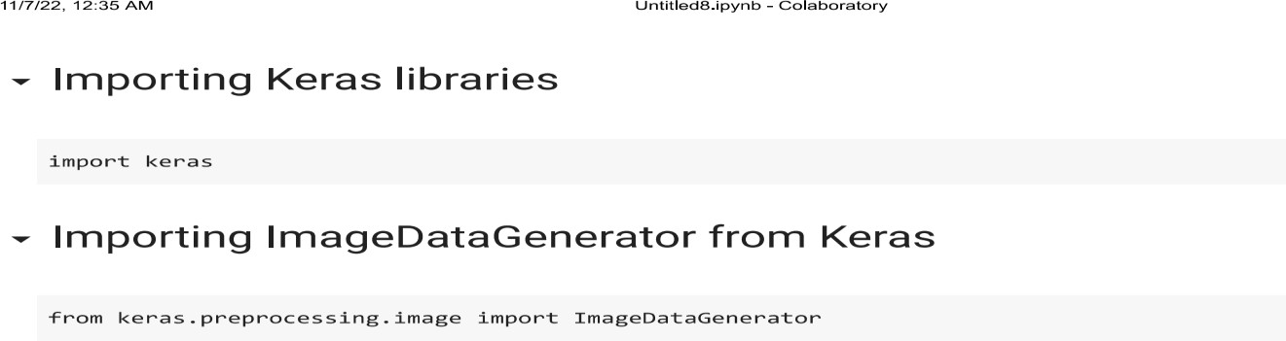

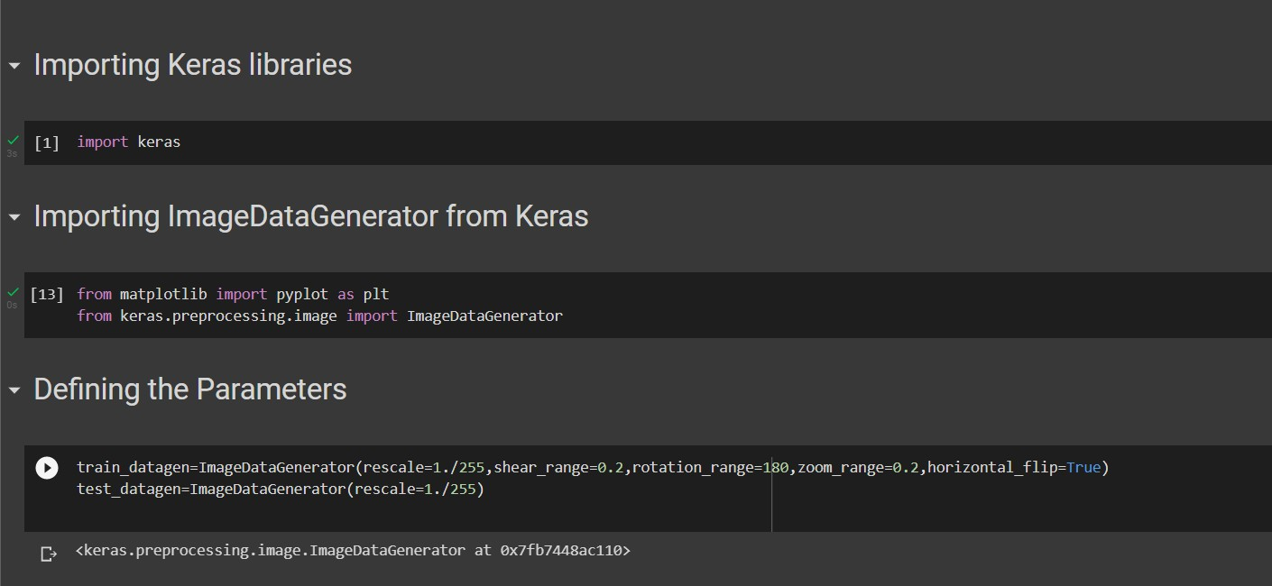

# APPLYING ImageDataGenerator to train dataset:

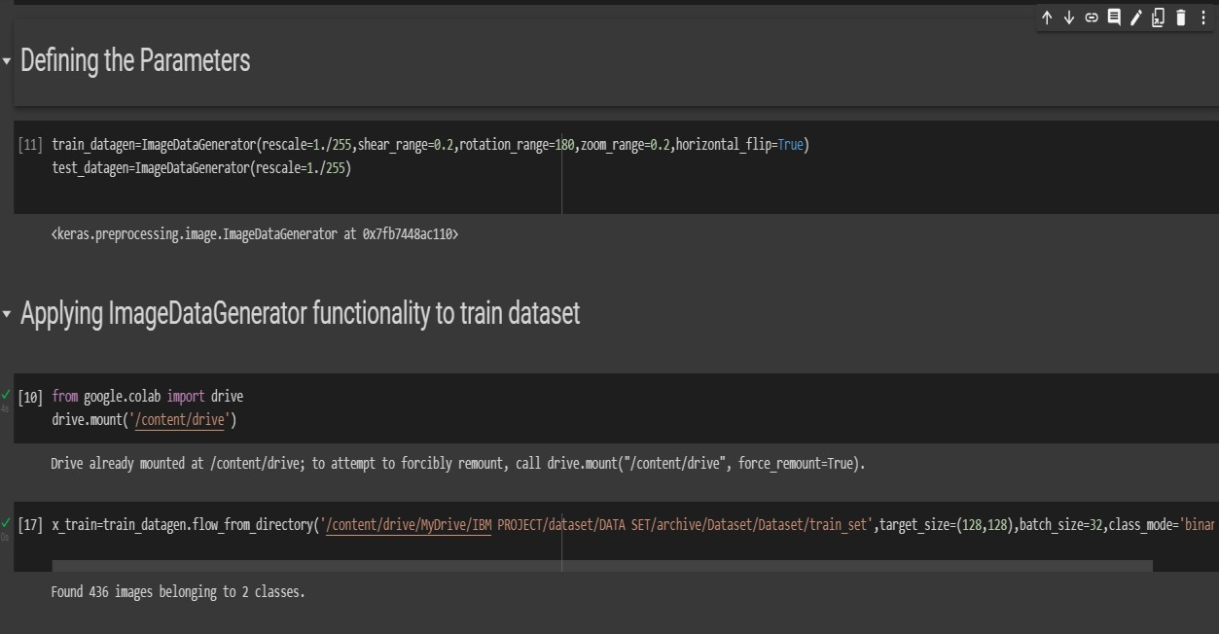ply**flow_from_directory ( )**methodfor Train folder.

# APPLYING ImageDataGenerator to test dataset:

Applying the **flow_from_directory ( )** methodfortest folder.

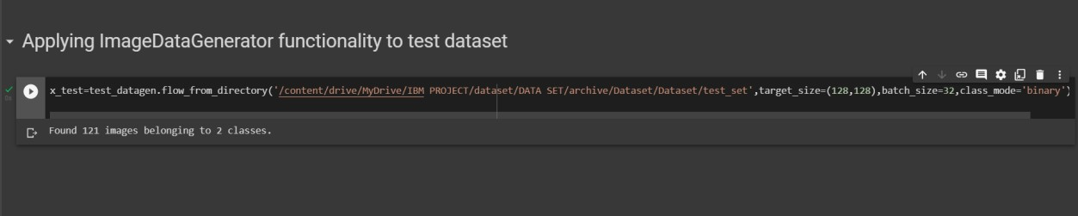

# IMPORTING MODEL BUILDING LIBRARIES:

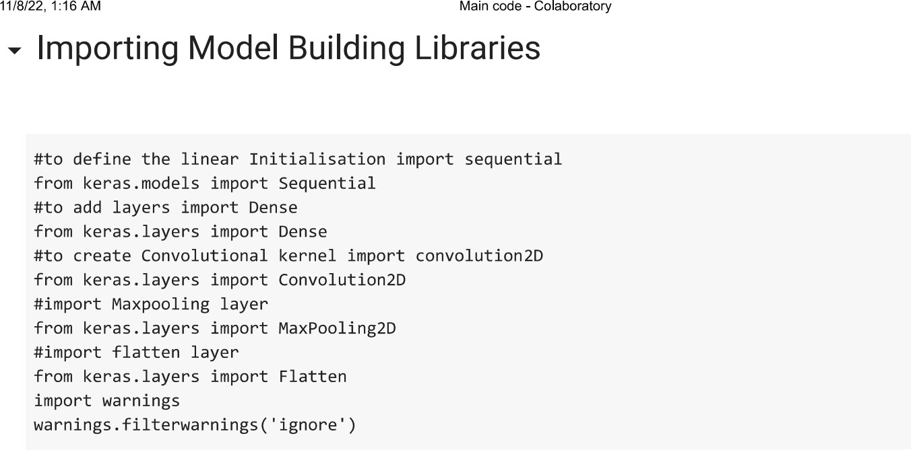

## INITIALIZING THE MODEL:

